EXPERIMENT 1

COMPUTER NETWORK COMPONENTS

- NIC CARD

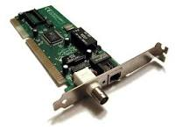

- NIC stands for Network Interface Card.
- NIC is one of the major and imperative components to associate a system to the network.

- REPEATER

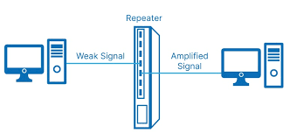

- Repeater job is to regenerate the signal over the same network before the signal becomes too weak or corrupted to extend the length to which the signal can be transmitted over the same network.

- HUB
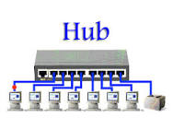
- A hub is a basically multi-port repeater. A hub connects multiple wires coming from different branches.
- Hubs cannot filter data, so data packets are sent to all connected devices.

- SWITCH
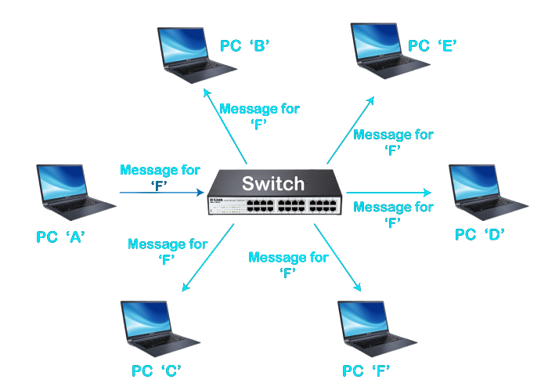

- A switch is a multiport bridge with a buffer and a design that can boost efficiency(a large number of ports imply less traffic) and performance.
- The switch can perform error checking before forwarding data, which makes it very efficient as it does not forward packets that have errors and forward good packets selectively to the correct port only.

- BRIDGE

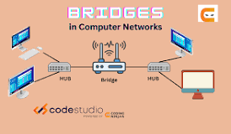
- A bridge is a repeater, with add on the functionality of filtering content by reading the MAC addresses of the source and destination.
- It is also used for interconnecting two LANs working on the same protocol.

- ROUTER
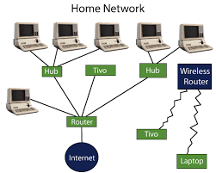
- A router is a device like a switch that routes data packets based on their IP addresses.
- The router is mainly a Network Layer device. Routers normally connect LANs and WANs and have a dynamically updating routing table based on which they make decisions on routing the data packets. The router divides the broadcast domains of hosts connected through it.

- GATEWAY

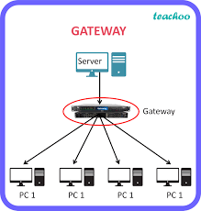
- A gateway, as the name suggests, is a passage to connect two networks that may work upon different networking models. They work as messenger agents that take data from one system, interpret it, and transfer it to another system.
- Gateways are also called protocol converters and can operate at any network layer. Gateways are generally more complex than switches or routers. A gateway is also called a protocol converter

- FIREWALL
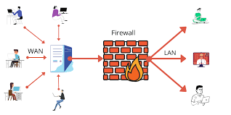
- A firewall is a network security device that monitors incoming and outgoing network traffic and decides whether to allow or block specific traffic based on a defined set of security rules.

